Create a Test Plan and save it

Click on the Save button

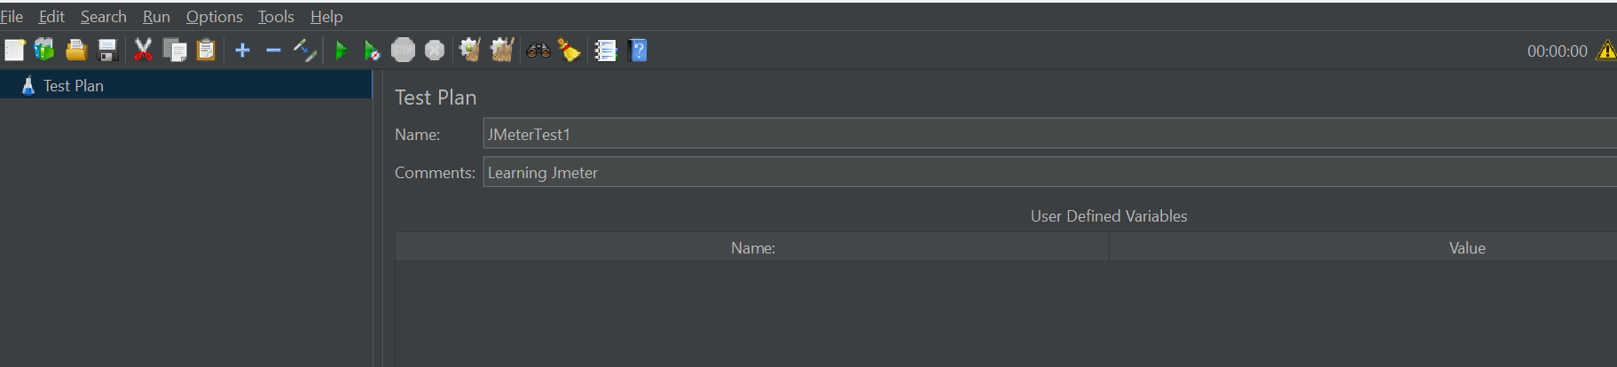

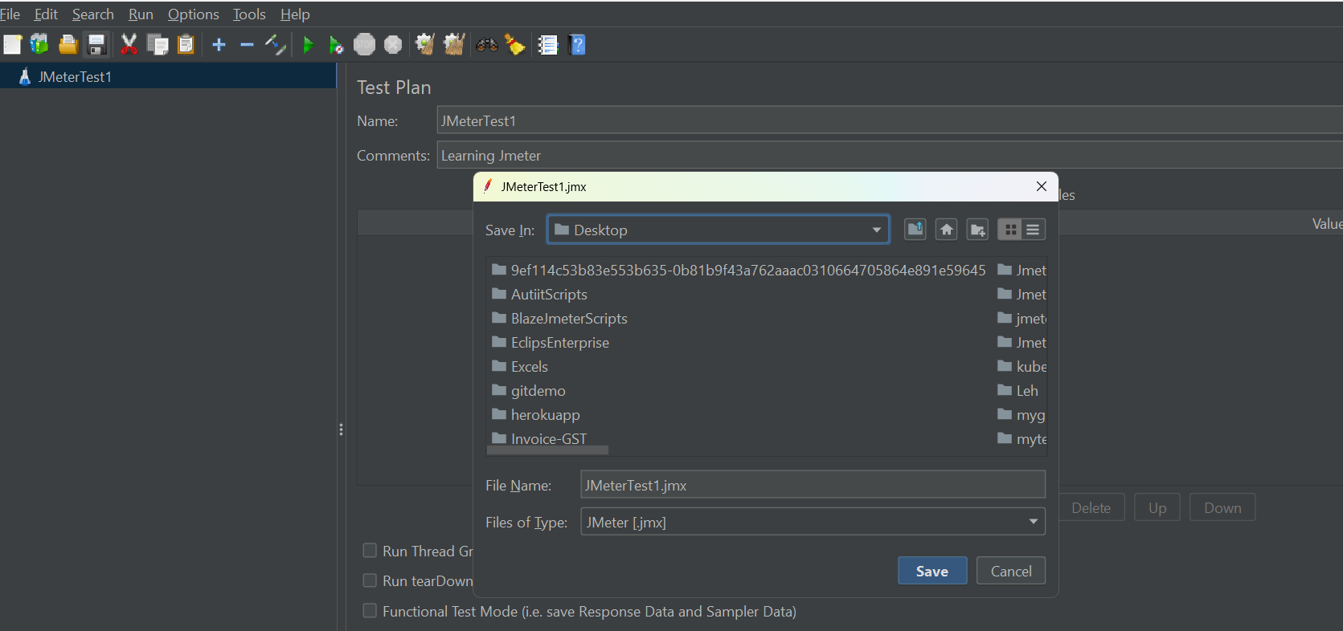

Click on save button. File will be saved.

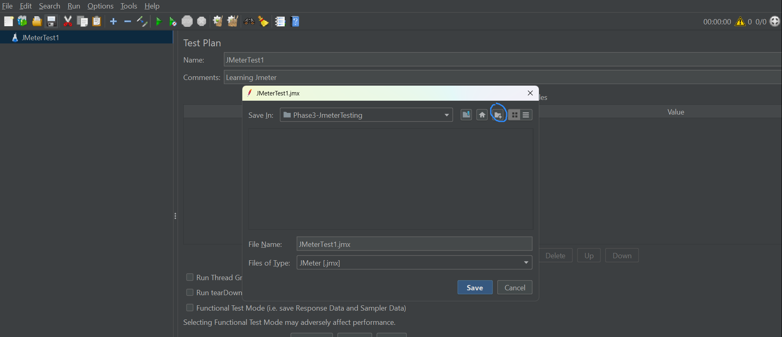

Add a thread group to a Teat plan

Right click of Test Plan -🡪 Go to Add🡪 go to Thread 🡪Click on ThreadGroup

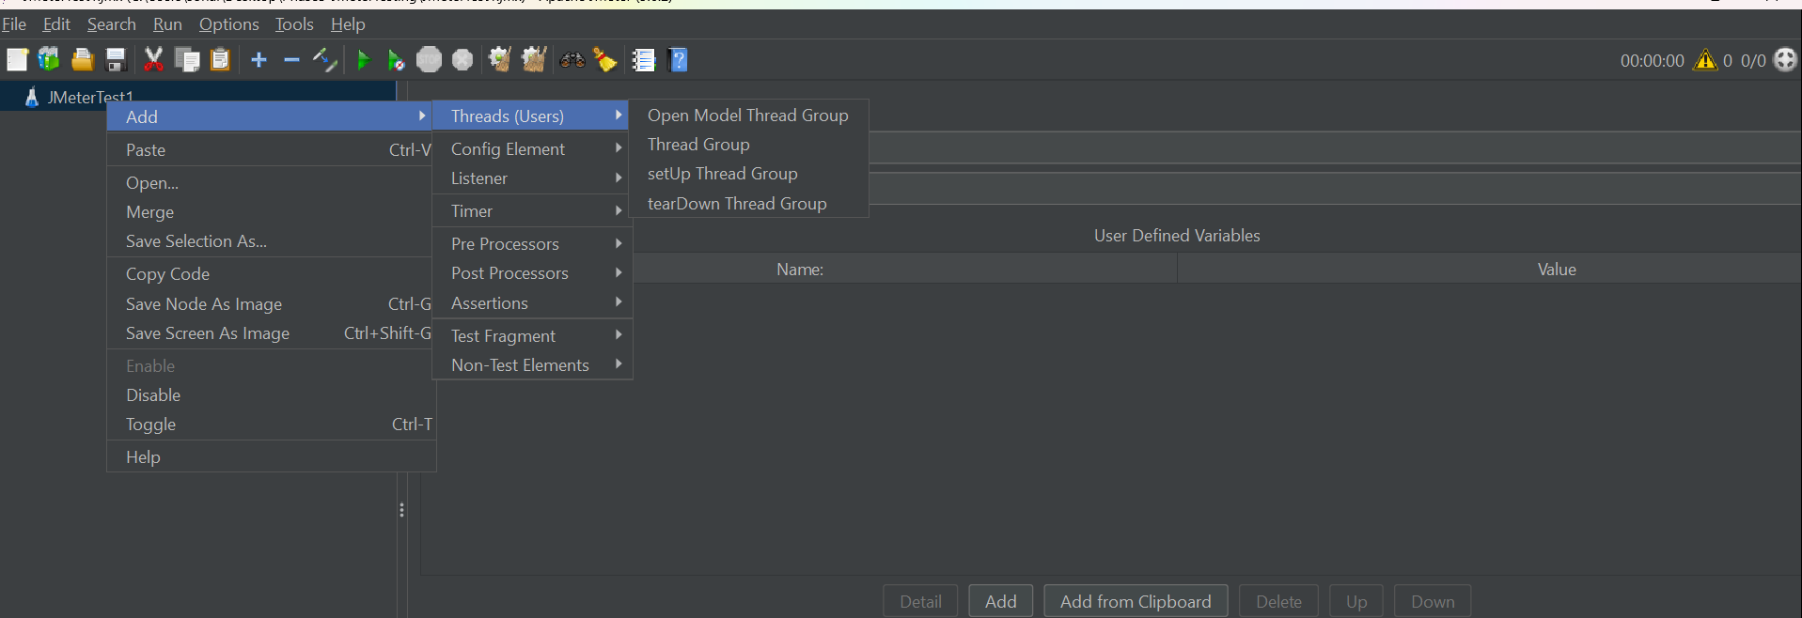

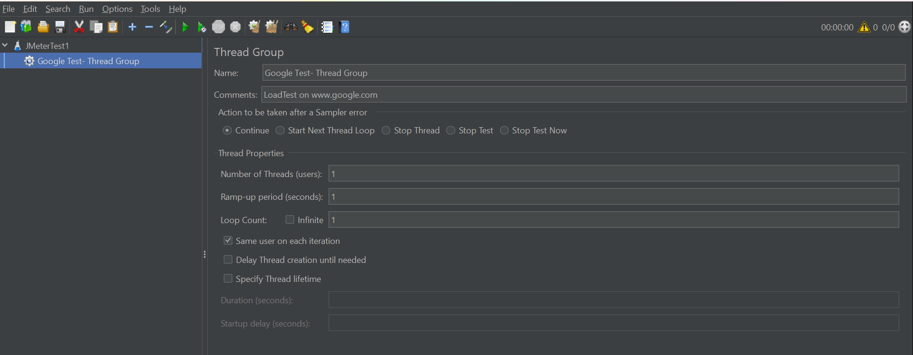

Recording script using Jmeter

To do this, first we have to set up proxy server on our laptop

Go to laptop search box 🡪 go to proxy settings

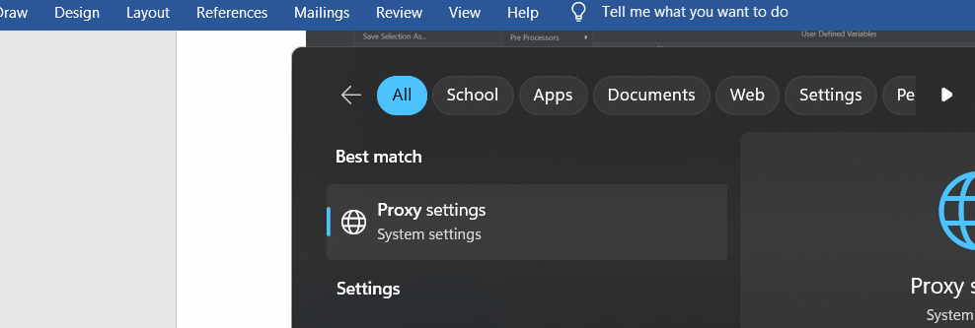

Set off for automatic detect settings

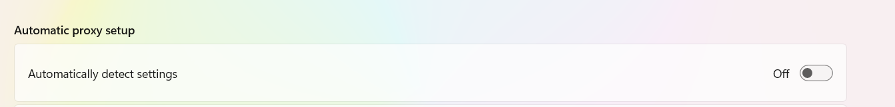

We will go to manual proxy setup -> click on set up 🡪 click on use a proxy server -> click on Save button.

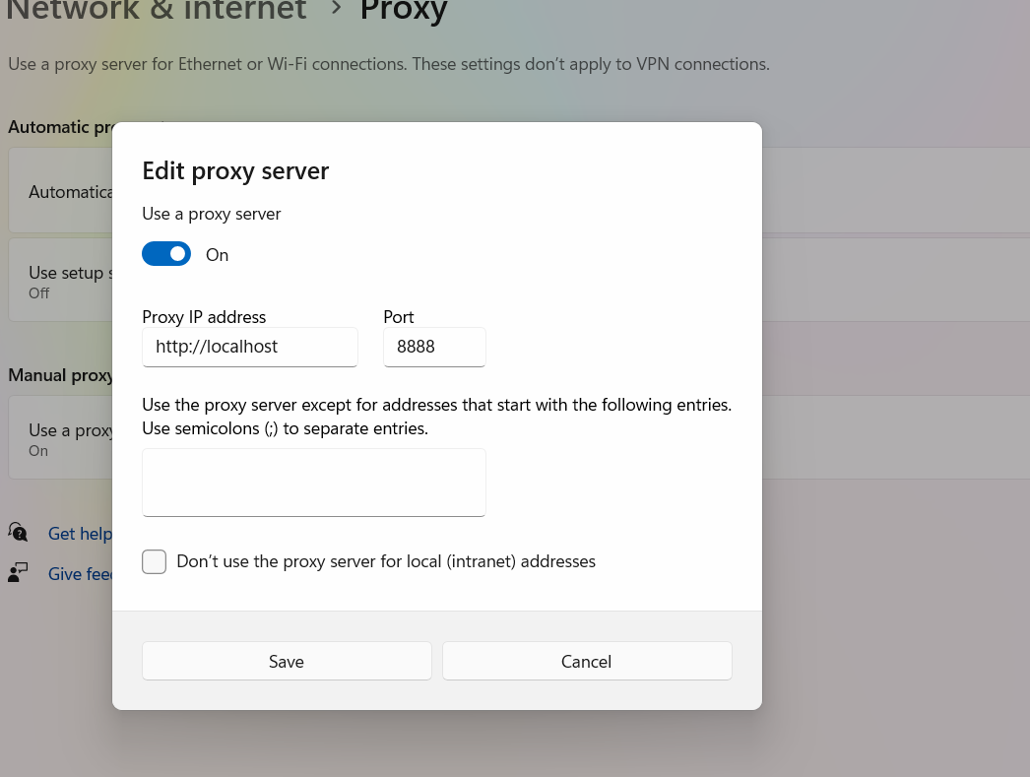

Now go to JMeter and add the recording elements:

Right click on Test Plan 🡪 Add 🡪 Non test elements 🡪 Https Test Script Recorder

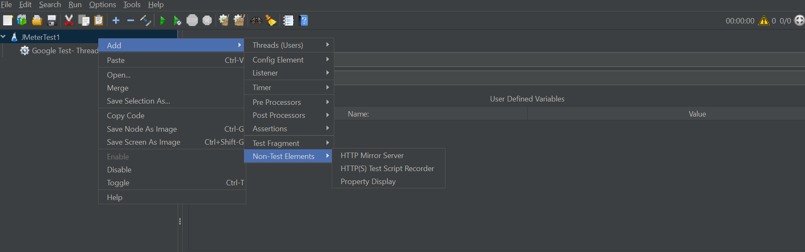

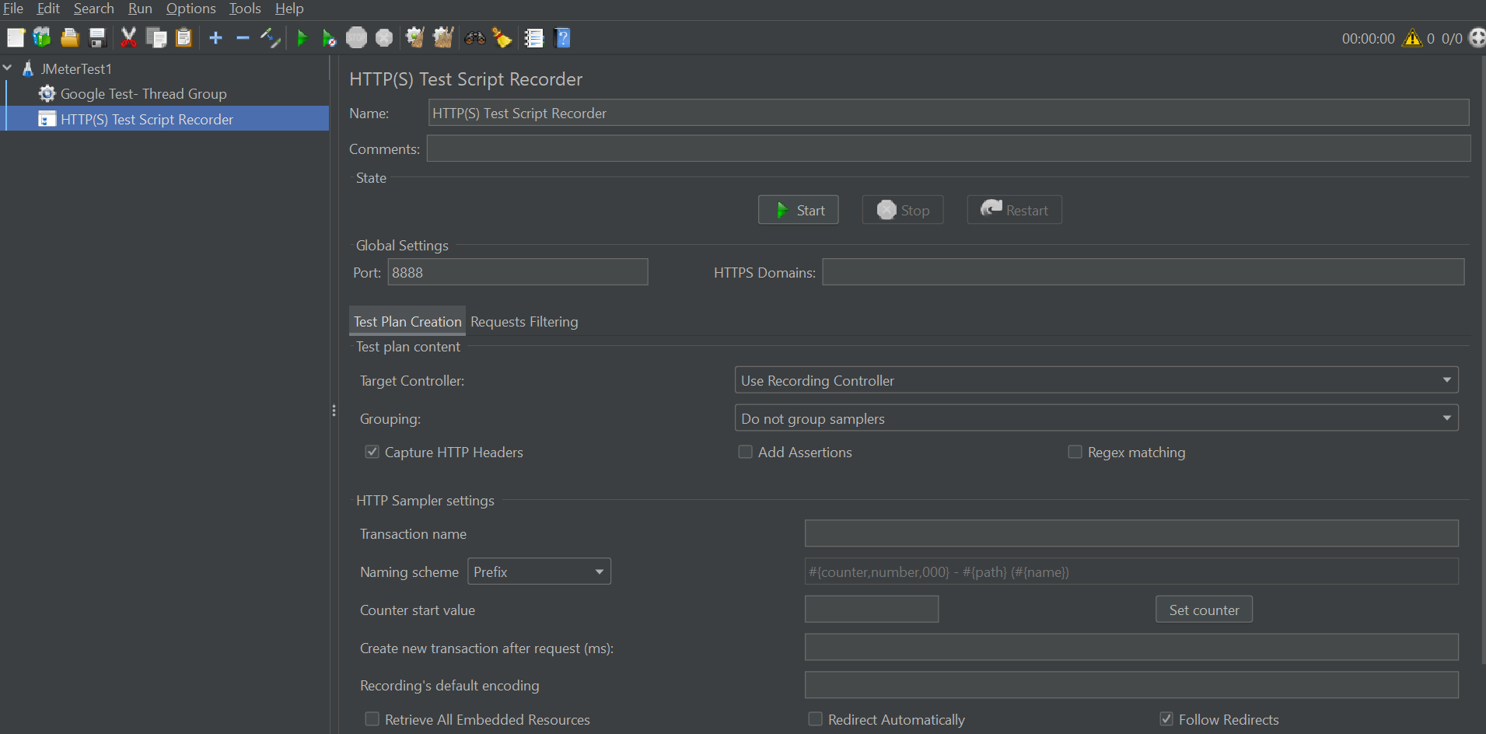

Add the recording controller to the thread group

Right click on thread group 🡪 add 🡪 logic controllers 🡪 Recording controller

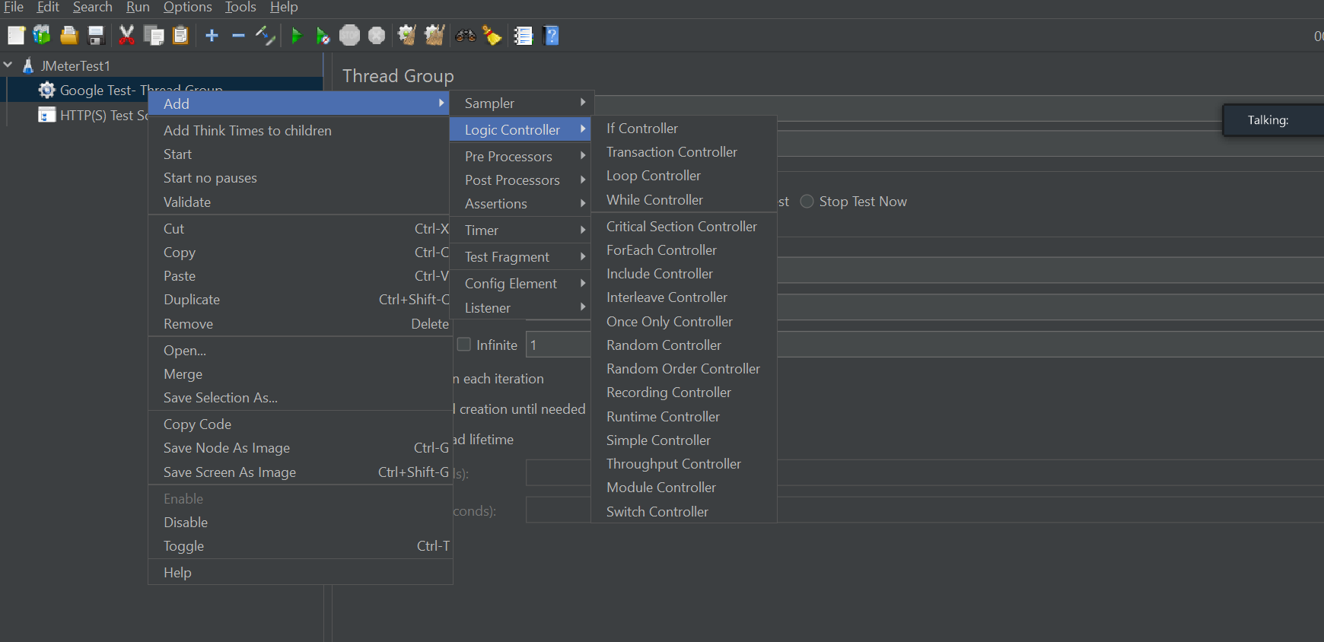

Select the recording controller in HTTP Tets Script recorder.

Click on Start button 🡪 click ok on the certificate adding request

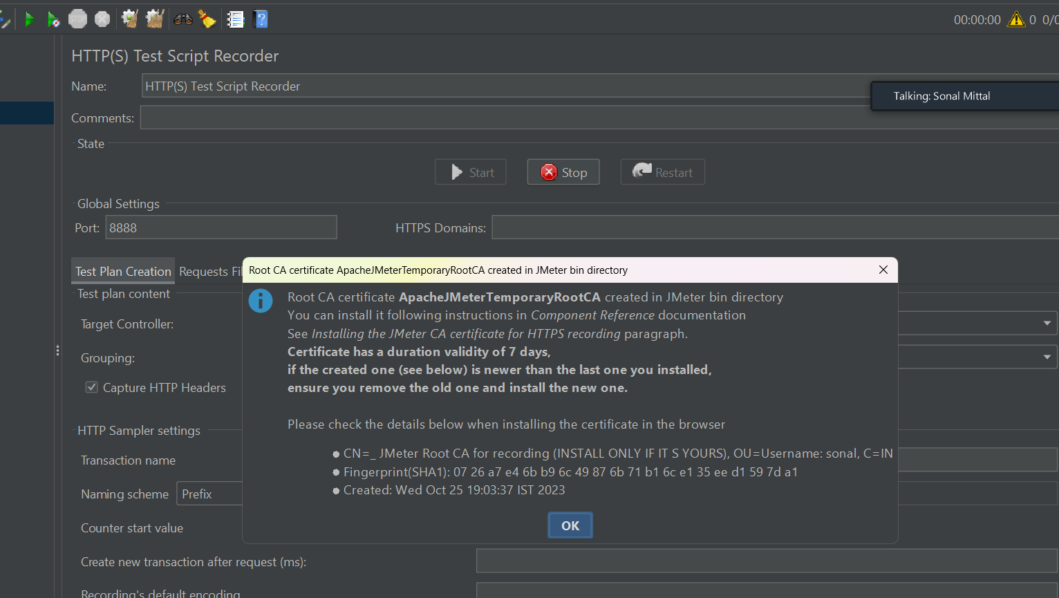

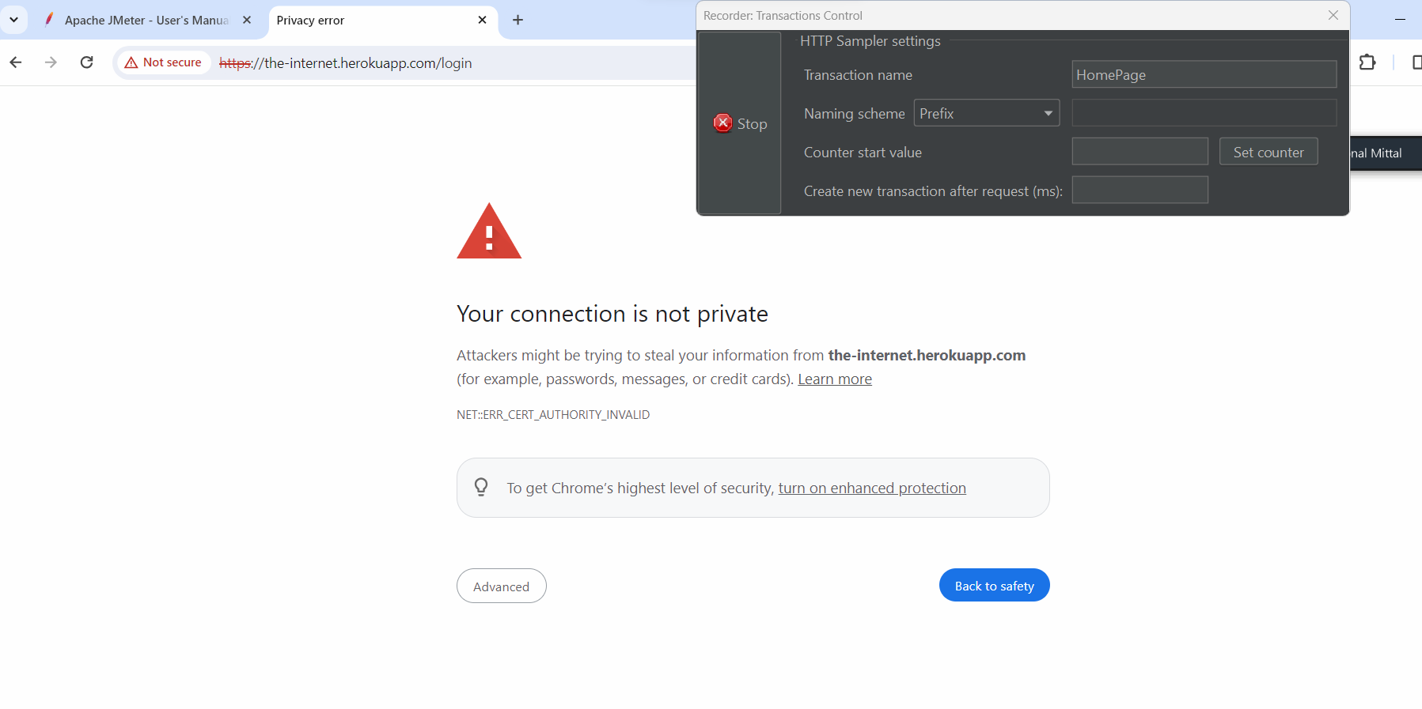

Click on advance🡪 click on proceed to internetheroku app

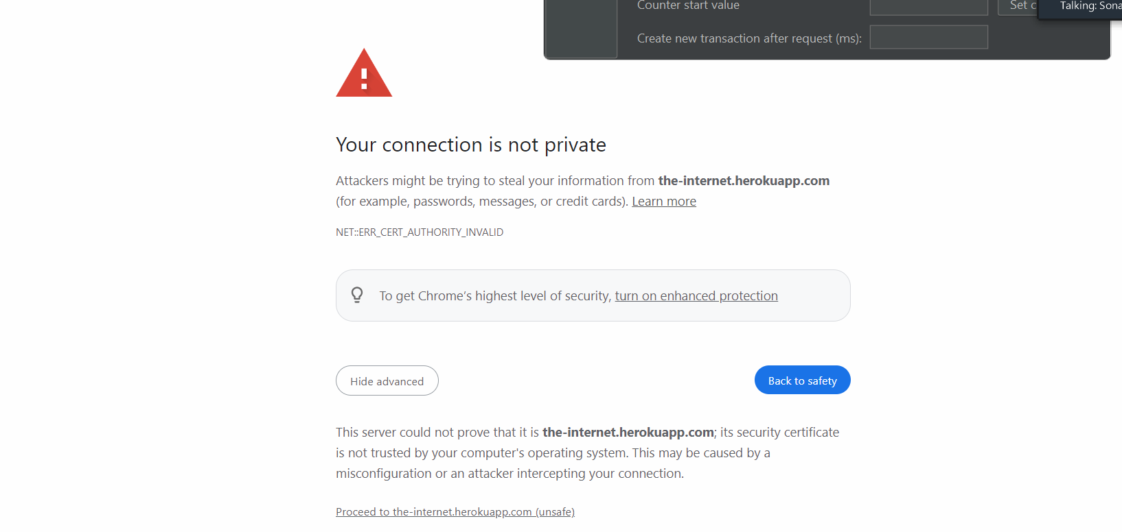

Record transaction tologinto the application

After click on login button, create anew transaction as logout

Click on logout button

Click on stop button on transaction control.

Now under recording controller, you will see the recored scripts

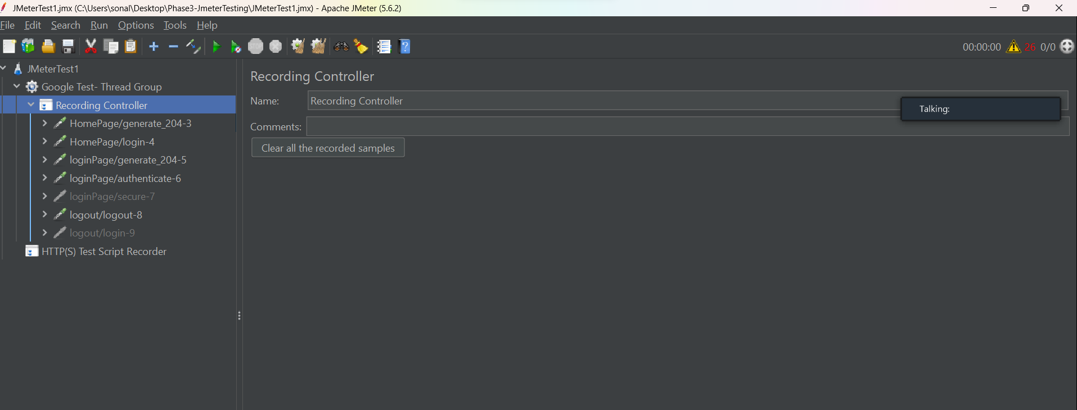

Right click and remove the request which have server name or ip and gstatic.com

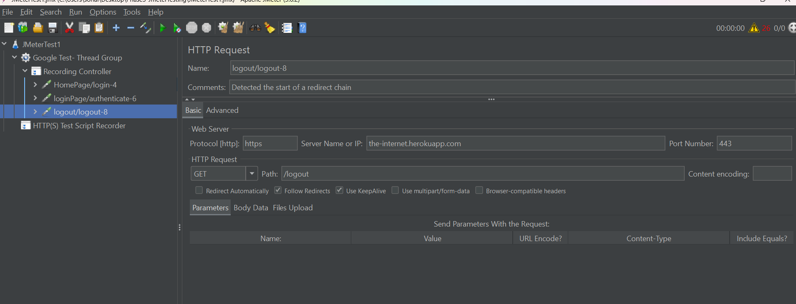

Now move the recorded transactions in Simple Controller

Simple controller is just like a folder that holds your test scripts

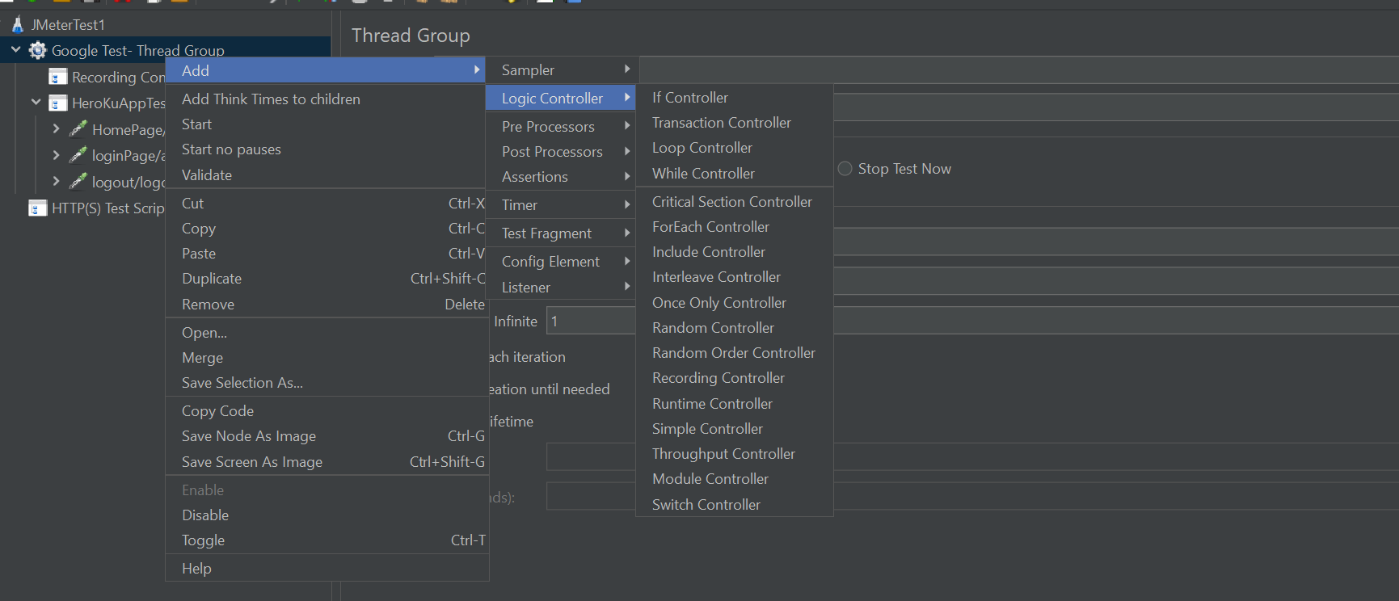

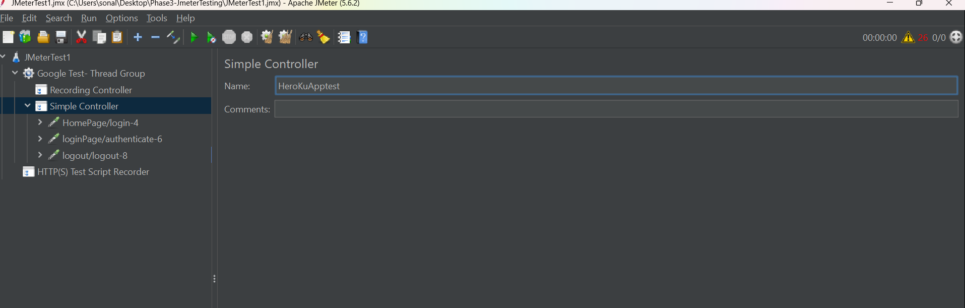

Add a Listeners to the thread group

ThreadGroup🡪Add -> Listners🡪 View results tree

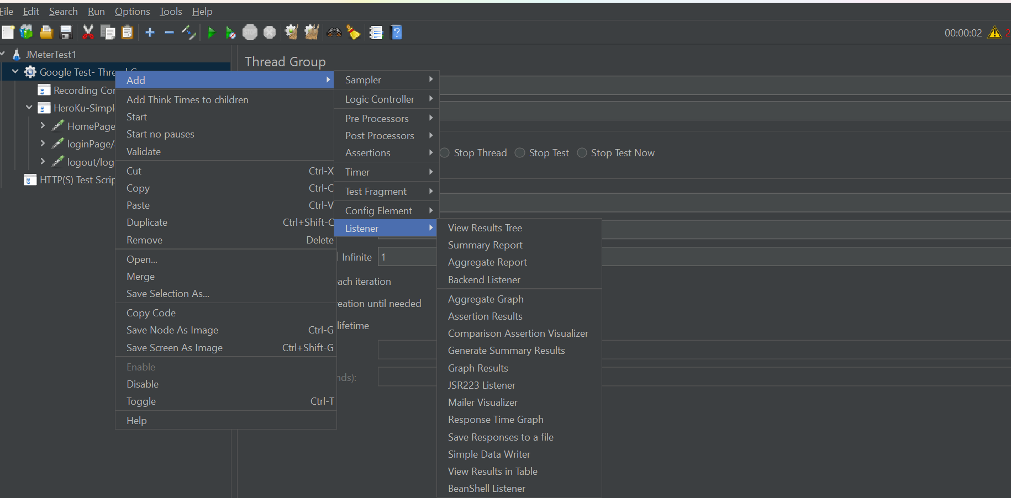

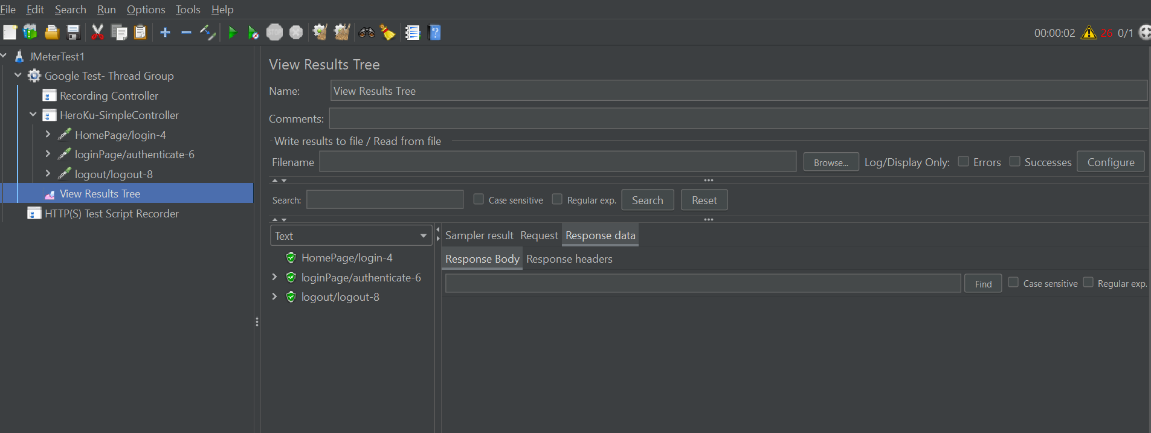

Loop and runtime Controller

Create 3 simple controllers and place you samples in each of the controller

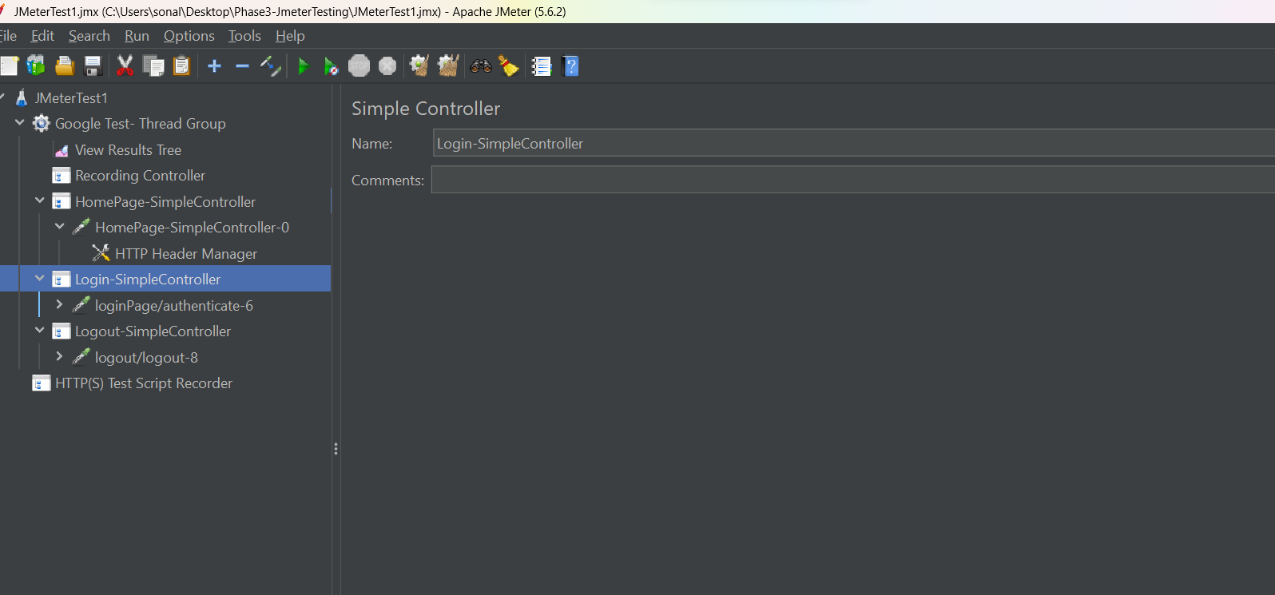

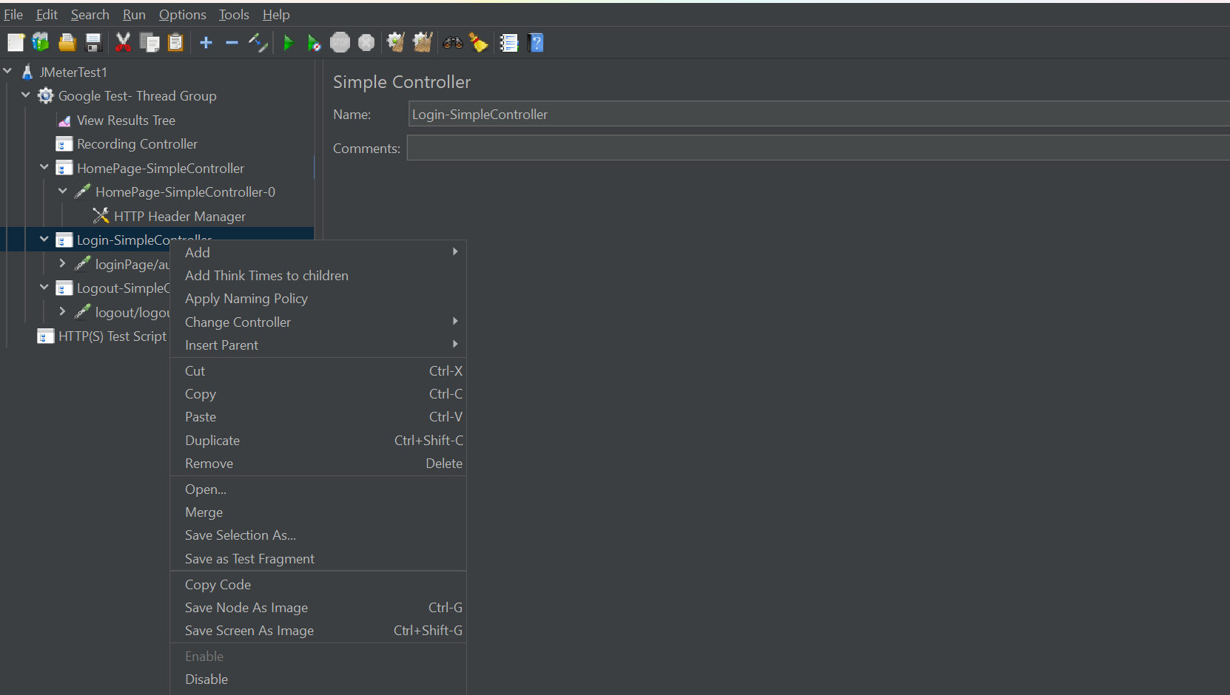

Now we have the thread group with Loop count as 1

So all transaction by default will run only once with 1 user

But lets say in the entire testing I want to run HomePage transaction 3 times and rest all transaction should run once🡪 then we can use loop Controller

Loop controller🡪 run a transaction multiple times

We can change simple controller to Loop controller and loop count for that transaction

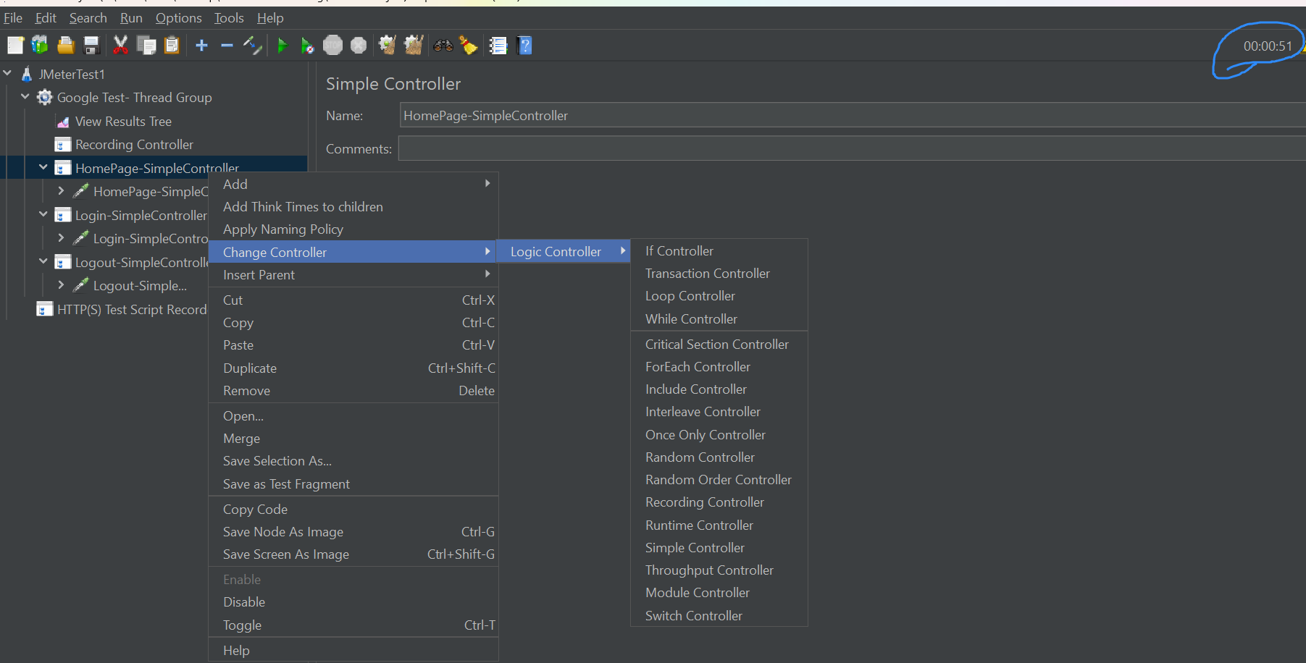

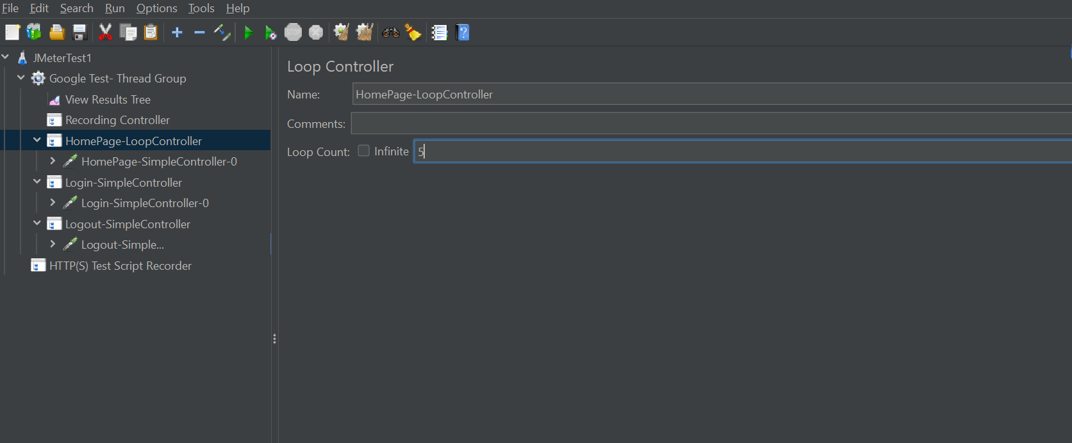

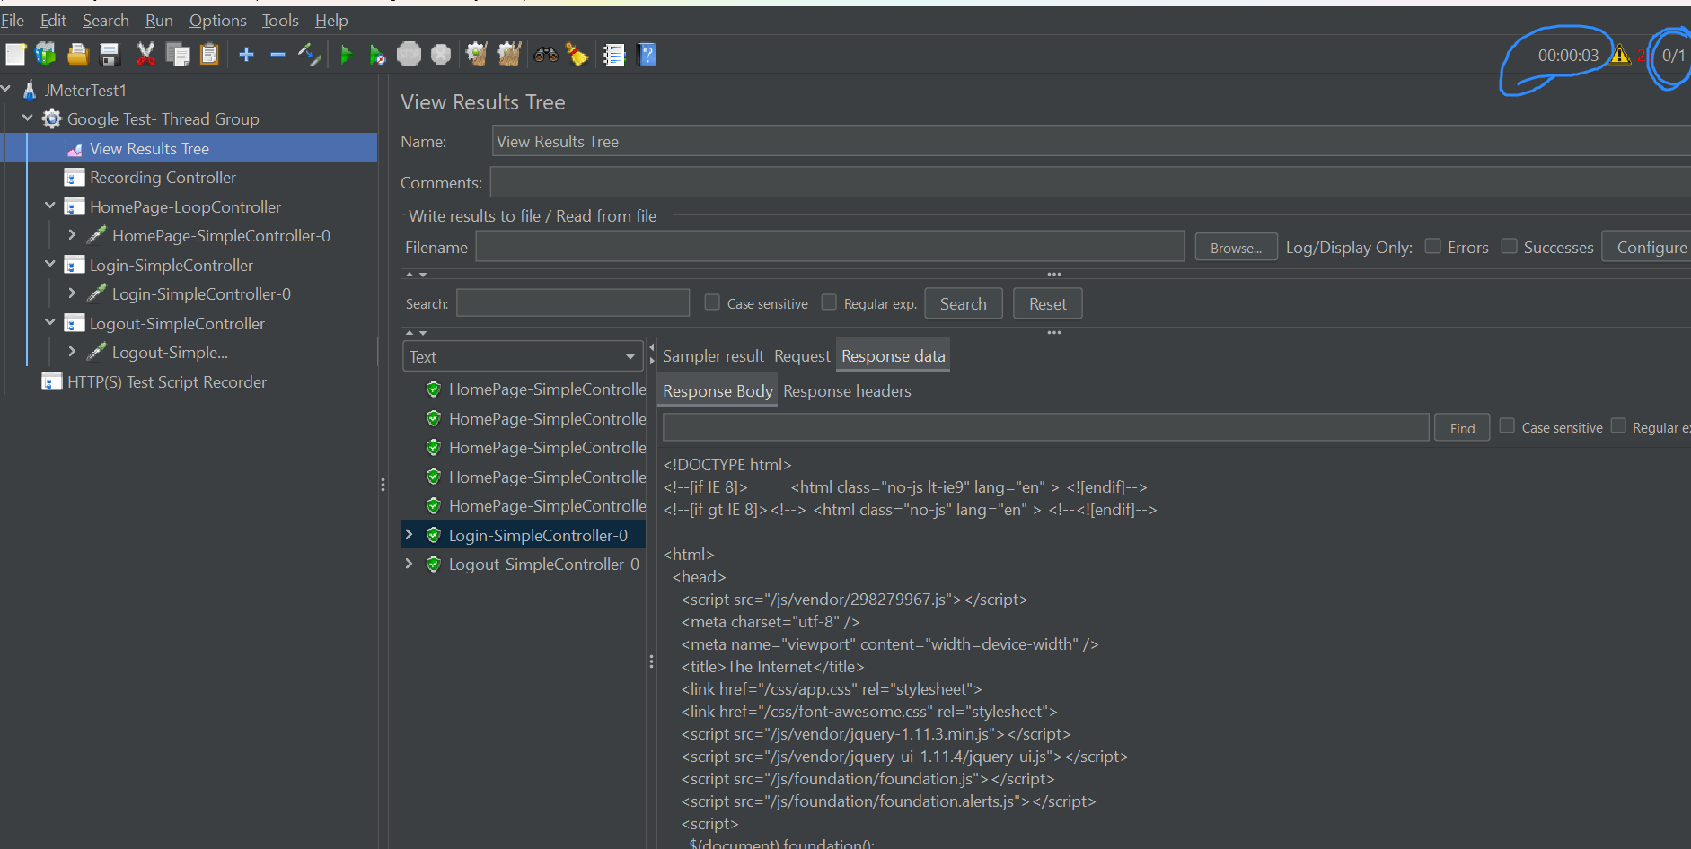

Now add the runtime controller to thread group

Disbale the lopp controller

Copy the homepage sampler in Runtime controller

In runtime controller🡪 give runtime = 10 sec 🡺 this sample is going to execute continuously for 10 seconds

